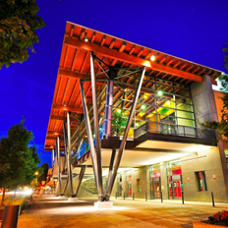

IAWP
The 2014 Oregon IAWP Conference is designed to:
OREGON CHAPTER
2014 EDUCATIONAL CONFERENCE
April 11, 2014
The Salem
Convention Center
Salem, Oregon

Enhance - Individual competence, knowledge and proficiency of the workforce arena.

Provide - A forum for the exchange of information on proposed legislation and policy matters affecting these programs.

Foster - A close working relationship with organizations that have common concerns regarding the Workforce Development Arena.

Contribute – Toward the advancement of peace, goodwill and international understanding through world fellowship among persons engaged in these programs.

A sample of topics include:
- Welcome from Salem Mayor Anna Peterson
- “Happiness According to Siri” Professional Speaker Bonnie Milletto gives us a tongue-in-cheek celebration of happiness and laughter. Followed with an illustration of the “Steps to Daily Happiness.”
- Workforce Redesign – A panel of individuals with the answers for all your questions.

Schedule Overview Friday, April 11th
7:30 a.m. – Registration
8:00 a.m. – Opening Address
9:30 a.m. – General Session Speaker
11:15 a.m. – IAWP Awards Luncheon
1:00 p.m. – Legislative Updates
2:00 p.m. – General Session Panel
4:30 p.m. – Conference concludes

